RESEARCH AND DEVELOPMENT REPORT

TITLE : A SURVEY OF PRIM’S ALGORITHM
DONE BY DINESH K
BSC IT-A
ABSTRACT
Minimum spanning tree is a classical problem in graph theory that plays a key role in a broad domain of applications. This paper proposes a minimum spanning tree algorithm using Prim's approach on Nvidia GPU under CUDA architecture. By using new developed GPU-based Min-Reduction data parallel primitive in the key step of the algorithm, higher efficiency is achieved. Experimental results show that we obtain about 2 times speedup on Nvidia GTX260 GPU over the CPU implementation and 3 times speedup over non-primitives GPU implementation.

------------------------------------------------------------------------------------------------
Introduction:
Minimum spanning tree (MST) is a fundamental concept in classic graph theory. It is defined as follows: Given an undirected graph G = (V, E) with a weight mapping w : E → R, find a connected sub graph T = (V,E' ؿE) with |E'| = |V | -1 that minimizes the objective function ∑e∈E' w(e). Fig. 1 illustrates the MST concept described above. MST plays a key role in a broad domain of applications, including network organization, touring problems and VLSI layout. Moreover, they are typically only a part of more complex graph algorithms.
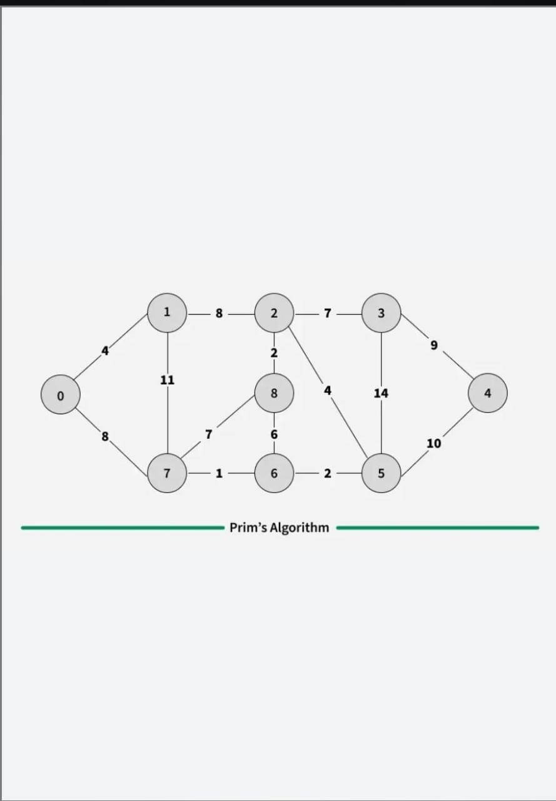

Working of the Prim's Algorithm
Step 1: Determine an arbitrary vertex as the starting vertex of the MST. We pick 0 in the below diagram.
Step 2: Follow steps 3 to 5 till there are vertices that are not included in the MST (known as fringe vertex).
Step 3: Find edges connecting any tree vertex with the fringe vertices.
Step 4: Find the minimum among these edges.
Step 5: Add the chosen edge to the MST. Since we consider only the edges that connect fringe vertices with the rest, we never get a cycle.
Step 6: Return the MST and exit
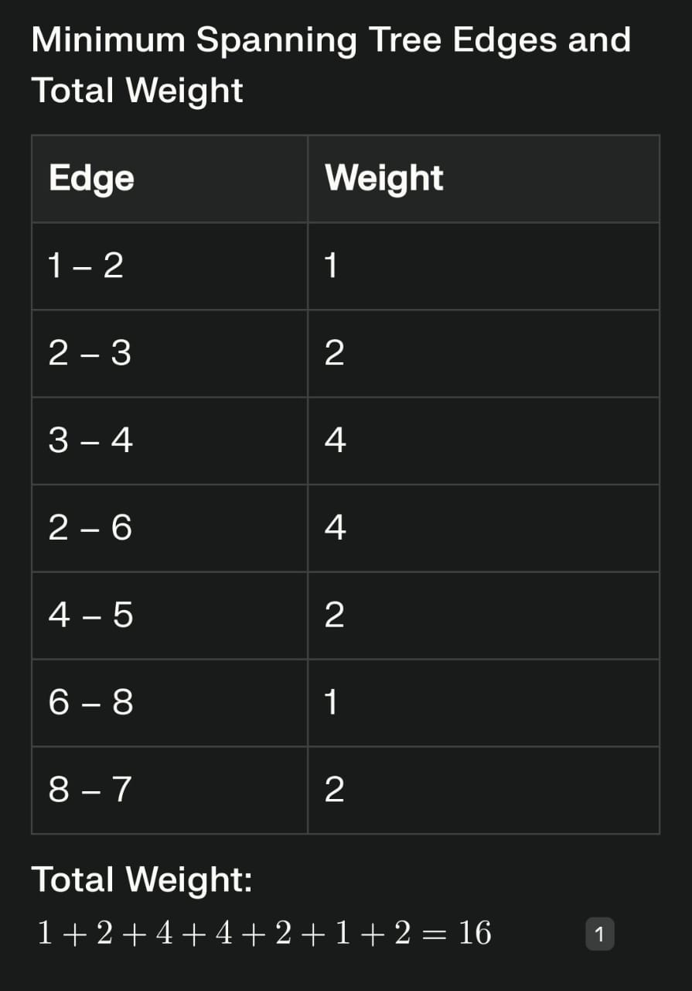
Time Complexity:
Adjacency Matrix Implementation: [O(V^2)], where [V] is the number of vertices. This is typical if you use a simple matrix and no heap or priority queue.
Adjacency List + Min-Heap (Priority Queue): [O((V + E) \log V)], where [E] is the number of edges. This is much more efficient for sparse graphs and is the most common implementation in competitive coding and real-world applications.
Fibonacci Heap: Can be reduced further to [O(E + V \log V)], but is harder to implement and rarely required for most practical purposes.
Space Complexity:
Adjacency Matrix Representation: [O(V^2)] due to the storage of all possible edge relationships.Adjacency List and Priority Queue: [O(V + E)], the sum of space for storing the adjacency list and maintaining the priority queue (min-heap), plus arrays for keys and visited nodes.
PSEUDO CODE IN JAVA:
// Assume: Graph is given as adjacency list, vertices are numbered 1 to N

function primMST(Graph, N):
boolean[] visited = new boolean[N+1] // Tracks visited vertices
int[] key = new int[N+1] // Weights to connect to tree
int[] parent = new int[N+1] // Parent vertex of MST

// Initialize all keys as INFINITY
for i = 1 to N:
key[i] = INFINITY
parent[i] = -1
visited[i] = false

key[1] = 0 // Start from vertex 1

// Repeat N times (for each vertex)
for count = 1 to N:
// Pick minimum key vertex not yet in MST
u = findMinKey(key, visited, N)
visited[u] = true

// Update keys/parents of adjacent vertices
for each vertex v adjacent to u:
if (!visited[v] && weight(u,v) < key[v]):
key[v] = weight(u,v)
parent[v] = u

// parent[] and key[] arrays contain the MST edges and weights

function findMinKey(key, visited, N):
min = INFINITY
minIndex = -1
for i = 1 to N:
if (!visited[i] && key[i] < min):
min = key[i]
minIndex = i
return minIndex

Advantages:
- Guarantees finding the Minimum Spanning Tree (MST) with the minimum total edge weight, giving an optimal solution in connected, weighted graphs. This makes it valuable for efficiency and cost-effectiveness in network design and similar applications.
- Efficient with proper data structures (like binary or Fibonacci heaps), achieving time complexity as good as [O((E+V) \log V)], where [E] is edges and [V] is vertices.
- Easy to understand and implement compared to some other MST algorithms.
- Particularly well-suited for dense graphs where the number of edges is high relative to vertices.
- Adaptable to distributed systems and parallel processing, enhancing versatility.

Disadvantages:
- Only applicable to connected graphs; if the graph is disconnected, Prim's algorithm must be applied separately on each component.
- Performance can degrade on very dense graphs due to the need to process many edges.
- Uses additional memory for priority queues, which can be a limitation for very large graphs.
- The MST result may depend on the starting node, which can affect consistency if such consistency is required.
- Less efficient for sparse graphs compared to algorithms like Kruskal's.

Real-Time Applications of Prim’s Algorithm
- Network Design: Used to design efficient computer, electrical, water supply, or road networks so that all nodes (cities, computers, pipes) are connected at minimum total cost, without redundancy.
- Telecommunication Networks: Determines the most cost-effective layout for linking telecom towers or stations, minimizing the length of cabling required.
- Transportation Routing: Plans railway tracks, highways, and logistics pipelines for industries to reduce construction costs while ensuring full connectivity.
- Circuit Design: Helps in the layout of circuit components by minimizing the total wire length needed to connect all points without closed loops.
- Cluster Analysis: In machine learning and data mining, Prim's algorithm assists in creating hierarchical clusters by connecting similar data points efficiently.
- Approximation Solutions: Used as a subroutine in algorithms for other combinatorial optimization problems, like the traveling salesman problem.

Conclusion:
Prim's algorithm is a highly effective and widely used greedy method for constructing a minimum spanning tree (MST) in a connected, undirected weighted graph, ensuring all nodes are connected with the smallest possible total edge weight.

